# Useful functions in this project

1. **Useful tricks in coding and debugging**  
   -ctrl+c: interrupt the running program in MATLAB  
   -command+0 (Mac os): switch to command window  
   -sca: exit PTB and close all textures and buffers  
   -clear all; close all; clc  
   -image: draw an image matrix, useful for examining your matrix variable outside PTB.  
   -Show help of a certain function xxxx: “help xxxx” or “doc xxxx”
2. **PTB Screen function**  
   -Type Screen(‘xxxx?’) to show help for sub-function xxxx  
   -Screen(‘CloseAll’) / sca: exit PTB and close all textures and buffers  
   -Screen(‘Close’): close specific texture or buffer  
   -Screen('Preference', 'SkipSyncTests', 1): skip screen synchronization check, useful when you test your script on laptop.  
   -Screen('OpenWindow'): initialize PTB  
   -Screen(‘OpenOffscreenWindow’): Open an offscreen buffer or canvas, with which you can quickly display stimulus later.  
   -Screen('SelectStereoDrawBuffer'): when you want to draw stereo stimulus  
   -Screen('Flip'): clears anything on the current screen and replaces it with images in the offscreen buffer.
3. **Draw stimulus (on offscreen)**  
   -Screen('FillOval'): draw an oval  
   -Screen('DrawText'): present texts on screen  
   -[x,y]=meshgrid(1:100,1:100): create a Cartesian gird  
   -imrotate: rotate an image matrix.  
   - Screen('MakeTexture'): Convert the image matrix into an OpenGL texture, so that you could draw them onto your screen  
   -Screen('DrawTexture’): draw textures onto screen/window
4. **“Rect” position**-"rect" is in screen coordinates to define the position of your stimulus in many cases. It is a 4-element vector where each number indicates [left, top, right, bottom] respectively in pixels and zero corresponds to the top left corner.   
   -Type help PsychRects to get a list of other useful rect-related functions-RectCenter: return the center x and y position of a rect  
   -CenterRectOnPoint: offsets a rect to center it around an x and y position
5. **Randomization**  
   -rng('shuffle'): Shuffle seeds for random number generator, otherwise the random number sequence would be the same every time when you restart MATLAB.  
   -rng also outputs the current state of the random number generator, useful if you want to exactly replicate your experiment conditions.  
   -randperm: randomly orders the numbers from 1:n and is invaluable for balanced randomization designs   
   -rand: uniformly distributed pseudorandom numbers between (0,1)
6. **Key press recording**  
   -KbName('UnifyKeyNames'): Unify key code for different operating system  
   -input: prompt for user input and save to variable  
   -KbWait: wait until key press  
   -KbName: map between key codes and key names.
7. **Time control**  
   -WaitSecs  
   -pause  
   -tic; toc  
   -GetSecs
8. **Save data into m file**-save

## Program procedures

## Wait for key press to start next trial

## 

1. Show fixation for 1200 ms



1. Show stimulus until subject’s responses (key press)

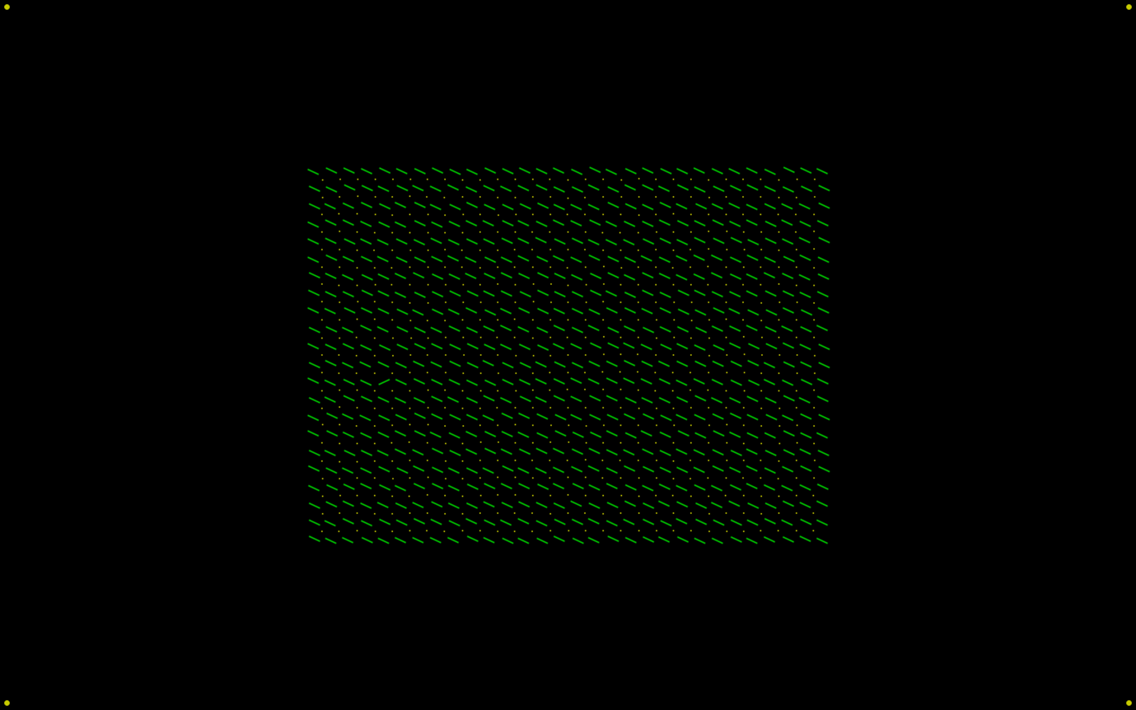

1. Wait for 700 ms



1. Repeat 1-4
2. Exit program until key press

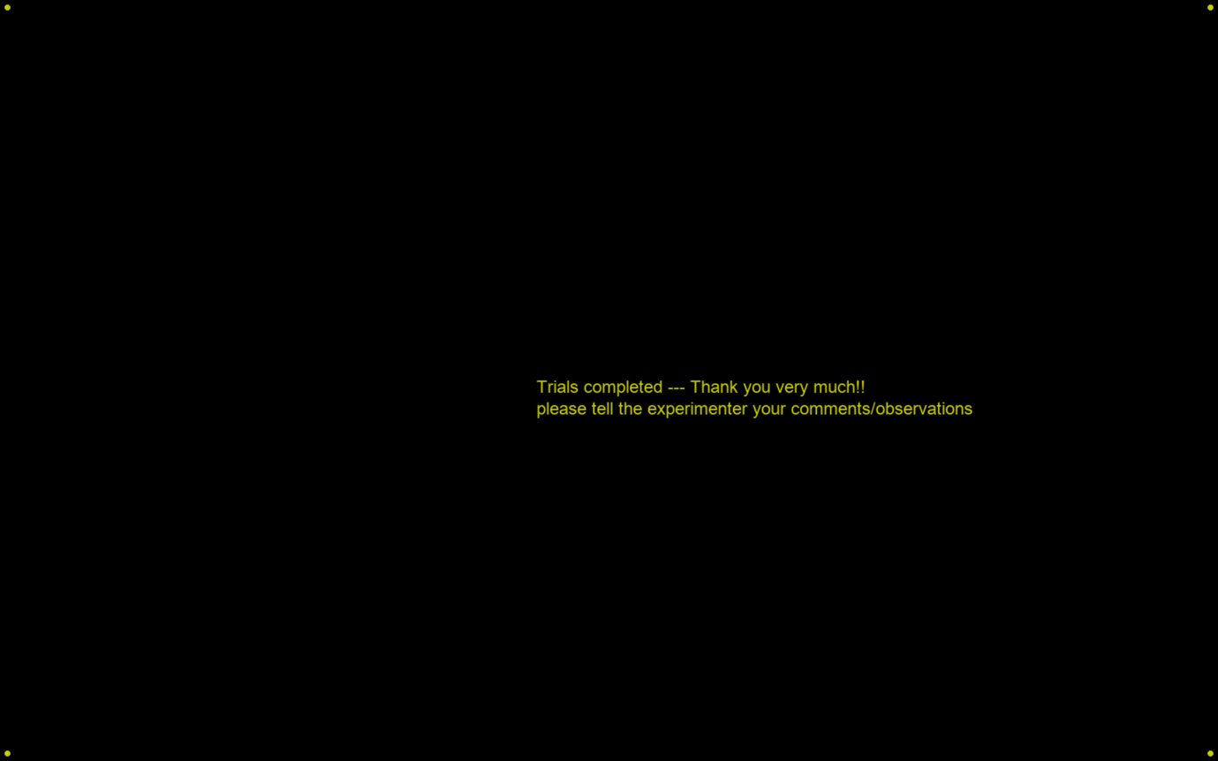

**Stimulus**



28 possible locations for target

30 bars

22 bars

We replicate the experiment 2 search task in paper (Zhaoping, L. 2008)

Task: find orientation singleton and report its location as in the left or right of the display as soon as possible.

Conditions in this session:

1. M (monocular): All bars are presented in the same eye only (either left or right eye).
2. B (binocular): All bars are presented identically to both eyes.
3. DC (dichoptic congruity): Target is both orientation and eye-of-origin singleton

Find other parameters (e.g. stimulus size in visual angle) in paper.

# Useful functions for data analysis

**Analysis**-load: load saved data in log file  
-strcmp: test whether two strings are identical  
-mean  
-std: to compute standard error: ste = std / sqrt(sample size)  
-squeeze: remove singleton dimensions  
-ttest: one-sample or paired-sample t-test

**Plot**   
-subplot: draw multiple figures in the same window  
-bar, errorbar, plot, boxplot  
-set(gca,'XTickLabel'): Add labels on x axis